**79920799**

Base URL:

<http://innovareacademics.in/journals/index.php/ijpps>

* Use the source URL because it’s difficult finds the correct journal with using the agreement URL.
* Select the issue from the issue list.

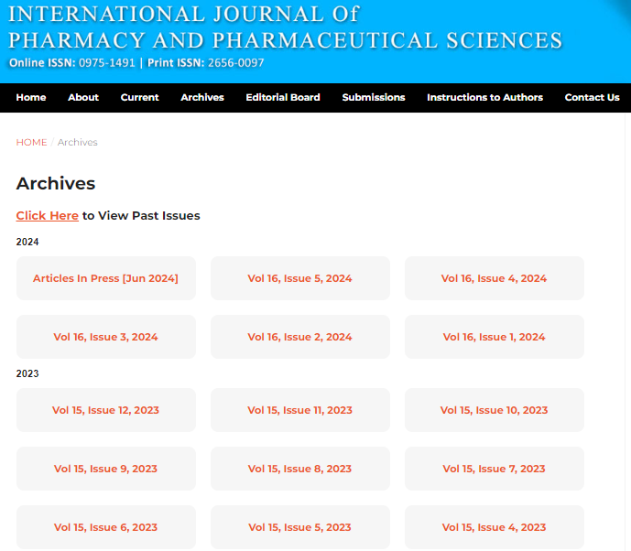

**Select the current issue from here.**

**Volume, issues**

* After selecting the issue content will appear here.

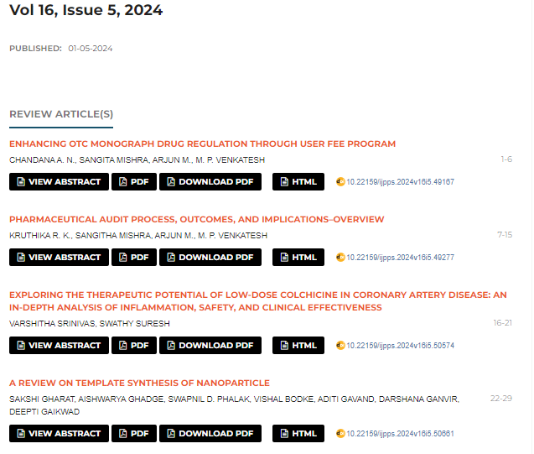

**Volume, issue**

**Publication Date**

Page range

* All required articles will be listed here

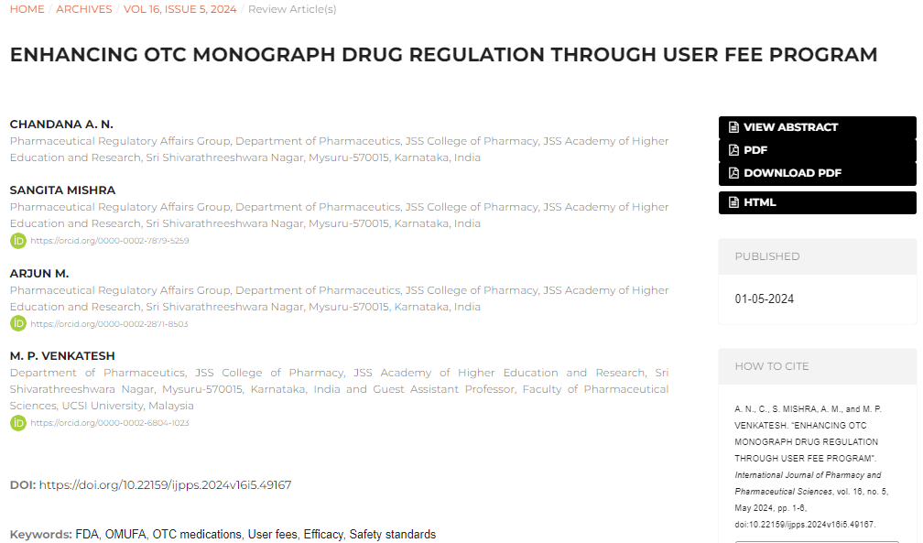

Title

**Click here to download the pdf**

**ORCID**

**DOI**